Part C –Business Plan – Australian Spatial Data Infrastructure Interoperability Demonstration Project

- EXECUTIVE SUMMARY

The Australian Spatial Data Infrastructure Interoperability Demonstration Project (IDP) is being submitted by the Australian Spatial Information Business Association (ASIBA) and the Open GIS Consortium (OGC). OGC will form an Australian subsidiary, OGC-Australia, prior to commencement of the project, and this subsidiary will assume OGC’s responsibilities at that stage.

Interoperability of databases containing crucial information and the location of topographic, environmental and infrastructure features is seen globally as the most significant information technology advance that can be taken to support incident and asset management and decision making by industry and government.

Interoperability will be vital to future Australian research, decision making, asset management and issues management. In this increasingly complex, competitive and insecure world, these disciplines need to be informed by immediate access to geospatial data held in thousands of databases around the country.

Databases held by various organisations, geographically spread and with data stored in various forms and formats, must be able to be brought together in real time to enable organisations to visualise, analyse, determine risk and to respond to current situations. The power of a spatial or GIS database is that it combines data from various sources, enabling organisations to plan and respond effectively and quickly.

The threat of terrorist attack, or a natural disaster in Australia, brings into vivid focus the need to harness technology to detect and respond to threats and critical incidents.
General Peter Cosgrove, Chief of the Defence Force, made a compelling case for development of the spatial industry in a speech to ASIBA on 10 October 2002. He said:
- “… knowing the precise location of your assets, and those of your adversary, is critical when conducting military operations…’
- ‘ The vast majority of national security issues have geospatial dimensions …’
- ‘ It is important from both a military and civilian perspective that we have high quality, up to date, spatial information …’
- ‘We are looking to industry to develop new and innovative tools for exploiting, analysing and visualising geospatial data.’
- ‘… the development of a single, global, geospatial information infrastructure – allowing the client to roam across seamless, accurate geospatial data – remains a noble, if difficult, goal for all spatial organisations …’
- ‘We will expect industry to produce data to … specifications that permit interoperability with defence systems.”

The economic and social impact of the use of spatial information is demonstrated by a few examples:
- North Carolina used spatial information to map school buses routes, resulting in 500 fewer buses,15 million fewer miles travelled and a saving of two million gallons of fuel per year
- US researchers tracked and forecast outbreaks of Rift Valley Fever by spatially integrating data on geopolitics, climate, and infectious diseases
- The US Emergency Mapping and Data Center used spatial information to manage recovery logistics at the World Trade Center after September 11.

The IDP will draw on global technology to demonstrate leading edge spatial data system interoperability to Australian industry and government. The demonstration will establish real time access to spatial information from diverse data sources and use it to support the management of real-world critical situations in defence, security and emergency services. It will provide the foundation and proof-of-concept of a spatial information solution for tracking, monitoring, identifying and responding to potential threats, and protecting our communities. It will promote innovation and competitiveness, generate new export opportunities and begin the process of broad adoption of the technology by Australian industry.

The IDP will complement the development of the Australian Spatial Data Infrastructure, a national initiative to provide better access for all Australians to essential spatial data from different agencies.

- BACKGROUND/INTRODUCTION

Australia has in the last 7 years been actively involved, via a small number of progressive participants, in the development of open standards for geographic data exchange over the Internet, as developed by the OpenGIS ® Consortium (OGC). The Australian Spatial Data Infrastructure (ASDI) sub committee of the Australia and New Zealand Land Information Council (ANZLIC), has adopted OGC specifications as one of the enabling technologies for the Australian Spatial Data Infrastructure (ASDI).

Growing acceptance of OGC specifications has led to the planned establishment of a regional subsidiary of OGC in Australia, intended for incorporation mid 2003. International GIS software providers are releasing, or announcing to release, implementations of OGC interface specifications in the latest versions of their products. The significance of interoperability now becoming a reality is being realised by governments and industry all over the world.

All major Spatial Software vendors are now implementing compliance with OGC standards in their Commercial Off the Shelf (COTS) products.

There are a number of barriers to the takeup of the OGC standards:
- Practically all spatial commercial of the shelf software (COTS) deployed in Australia is from vendors outside Australia
- The vast majority of Australian systems integrators have very little awareness of, and experience with this new technology
- The Australian Spatial Data Directory (ASDD) – the Australian distributed registry of spatial data resources – is conceptually correct, but is essentially ineffective due to the difficulty of using it and finding information. It therefore requires a technical upgrade and awareness push to achieve full uptake and enable interoperability
- ANZLIC has designed the ASDI technical architecture, however a concerted effort from industry and government is required to incorporate the implementation of this architecture into the ASDI.

All these developments contribute to the proper conditions and timing for the project proposed in this submission. A project that will widely demonstrate the availability of these innovative technologies to Australian industry and marketplace, as well as provide a testbed demonstrator of Australian systems integration skills to the Australasian region and the rest of the world.

ASIBA has joined with OGC to develop the Australian Spatial Data Infrastructure Interoperability Demonstration Project (IDP).

ASIBA was recently formed to oversee the implementation of spatial industry actions which are primarily the responsibility of business, and to represent business in the implementation of joint actions with government, professional organisations and academia.

OGC is an international industry consortium of 254 companies, government agencies and universities participating in a consensus process to develop publicly available geoprocessing specifications. Open interfaces and protocols defined by OpenGIS® Specifications support interoperable solutions that "geo-enable" the Web, wireless and location-based services, and mainstream IT, and empower technology developers to make complex spatial information and services accessible and useful with all kinds of applications. OGC-Australia, which will be formed prior to commencement of the project, will assume OGC’s responsibilities at that stage.

The IDP will demonstrate, in an Australian context, efficient access to diverse spatial data sources through use of global best practice web services models and interoperability protocols and technologies. The IDP will demonstrate that digital data from diverse sources can be viewed and overlaid using commonly available web browsers.

The IDP will complement the Australian Spatial Data Infrastructure (ASDI) pilot project. It will widely demonstrate the availability of innovative interoperability and ASDI technologies to Australian industry and marketplace. It will also provide a demonstration of Australian Systems Integration skills to the region and the world.

The Vision and Mission of the IDP are:

Vision
Australian research, decision making, assets management and issues management informed by immediate access to geospatial data from multiple databases, creating economic and social benefits for the community, and opportunities for Australian industry to export new technological capability, services and intellectual property.

Mission
To demonstrate spatial data system interoperability by establishing real time access to spatial information from diverse, cross-jurisdictional data sources and using it to support the management of real-world critical situations in defence, security and emergency services. The IDP will access data using commonly available web browsers and global knowledge and technology.

Participants and Contributing Strengths
ASIBA and OGC-Australia will have overall management responsibility for the IDP. Table 1 below outlines the scope of the project and the project management and coordination task.

Table 1 – Outline of the Project’s Task Flow (High Level)
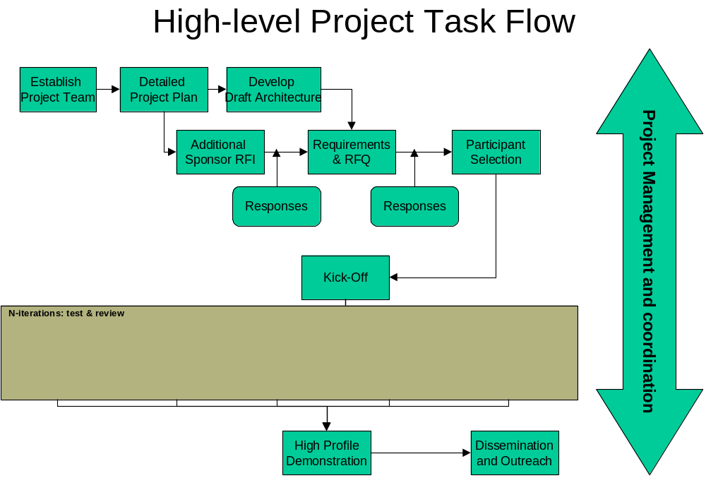

The IDP proposal has strong support from a wide range of industry and government organisations active in the development of spatial information. Supporters are grouped below in industry categories. There is some overlap between categories: for example, some service providers also produce software.

Software Providers

- ESRI - a leading international supplier of GIS software and technology. Its headquarters are in Redlands, California and it operates in Australia through its subsidiary, ESRI-AU. ESRI supports and participates in major standards and interoperability organisations and is on the OGC Board of Directors as well as the OGC Planning and Technical Committees. ESRI products include the ArcGIS system (ArcInfo, ArcView, etc)

- Intergraph - a major mapping and geospatial solutions provider with a widely used range of products based on GeoMedia technology. Intergraph has offices in several Australian states and the ACT and is a sponsor of the CRC for Spatial Information

- MapInfo - a major provider of mapping and GIS software and solutions, based in New York State and with a well established presence in Australia

- Amristar – a Western Australia based IT solutions company, whose iDelve product is a mapping technology for interactively presenting large collections of spatial data via the internet

- Oracle – a world leader in this field. Oracle has the GIS product Oracle9i and a strongly stated commitment to the OGC approach and strategy

Hardware Providers

- Sun Microsystems – a leading supplier of hardware and also of software and solutions, for the spatial industry

- SGI (previously Silicon Graphics Corp) – well known for its high end work stations and advanced graphics products, SGI has developed, within one of its priority areas, Defense and Security, specific solutions for homeland security

Data Providers/End Users

- Land and Property Information NSW (LPI NSW) – now part of the newly named Land NSW, has a key role in the NSW government application of GIS, as the agency responsible for land titles, valuations etc

- Public Sector Mapping Agencies Australia (PSMA) - a Government owned organisation operating commercially, whose aim is to complement rather than compete with fully commercial organisations

- Environment Australia - the Federal Department of Environment and Heritage, a major user of geospatial information

- Geoscience Australia - the national agency for geoscience research and geospatial information with a crucial role in regard to government involvement in GIS issues

- Defence Imagery and Geospatial Organisation, DIGO - a very significant government user of geospatial information whose expertise will be invaluable for the demonstration project, especially with regard to defence and security applications

- Western Australian Land Information System (WALIS) - a partnership of 27 State Government agencies, Local Government Authorities and private organisations dedicated to improving the management and use of the State’s land and geographic information

- Community Access to Natural Resources Information (CANRI) - provides information products tailored to community-based local and regional environmental management in New South Wales. It offers integrated access to maps and other data held at various internet sites by a diverse group of natural resource agencies and other stakeholders.

- National Oceans Office (NOO) is a Commonwealth Executive Agency with responsibility for coordinating the overall implementation and further development of Australia's Oceans Policy

- National Office for the Information Economy (NOIE) has a key responsibility to strengthen Australia’s participation in the information economy, for the benefit of all Australians and is the focal point for Commonwealth government coordination of information economy issues

- Australian Antarctic Division (AAD) is responsible for overseeing and delivering Australia's scientific program over our Antarctic Territory. (They have not been approached yet, but have shown a willingness to participate when a similar project was discussed several months ago.)

- National Land and Water Resources Audit (NLWRA) a partnership between all States, Territories and the Commonwealth, sharing and exchanging information and data on a vast array of topics to make the Audit one of the most ambitious programs on natural resources ever undertaken in Australia. The Audit’s Australian Natural Resources Atlas (the Atlas) is the web-based community interface to all the information prepared by the Audit.

- Queensland Spatial Information Industry Strategy (QSIIS) promotes easy access to relevant and reliable integrated spatial information for Queensland. It is a collaboration between the State Government, the Local Government Association of Queensland and the private sector through Spatial Queensland.

- Telstra – as Australia’s major telecommunications provider and with the most extensive telecommunications network, Telstra’s vast experience and knowledge base will be invaluable for the pilot project

- TXU Australia provides retail gas and electricity to business and consumers in Victoria and South Australia

- Citipower distributes electricity to Melbourne’s CBD and inner suburbs.

- Powercor is Victoria’s largest electricity distributor

- Sydney Water is a statutory State owned corporation, providing drinking water, wastewater services, and some stormwater services to the communities of Sydney, the Blue Mountains and the Illawarra.

Service Providers

- Sinclair Knight Merz (SKM) - a diversified engineering, science and technology consultancy of more than 3,400 staff with a major involvement in the spatial information industry. Services include Geographic Information Systems (GIS), photogrammetry, remote sensing, surveying, data conversion, mapping and spatial databases

- Navigate – with offices in Sydney and Canberra, is a well-established Australian company providing spatial systems integration and GIS consultancy services and also providing Australian national reference and cadastral datasets in many of the mainstream spatial formats

- Geomatic Technologies – Melbourne based company, providing spatially based business information products, applications and services; solutions offered include field-based asset data capture, web-mapping and workforce management applications

- Open GIS Consortium-Australia-The OGC itself is an international industry consortium of 254 companies, government agencies and universities participating in a consensus process to develop publicly available geoprocessing specifications. OGC-Australia will be the Australian subsidiary of OGC and is expected to be established in mid 2003

- Social Change Online - a Sydney based website developer servicing government departments and community organisations, with a strong capability in designing and using interactive maps on websites. The company has been a very active proponent of the OGC approach to GIS

- Raytheon - a major defence and aerospace systems provider. A key Raytheon priority is homeland security….“We provide state-of-the-art technology to detect, protect and respond to terrorism and provide Homeland Defense”

- SAAB Systems- SAAB is one of the world's leading high-technology companies with its main focus on defence, aviation and space

- The Boeing Company - the world's leading aerospace company and the largest manufacturer of satellites, commercial jetliners and military aircraft

- Itech Corporation – an Australian systems integration company with strong GIS capability and specialising in Industrial IT software and services, in particular in interoperability of disparate systems and databases. In Australia the company represents Eutech Cybernetics a global manufacturer of highly scalable information coordination and management software as well as internet security technology.

Academic and Research Institutions

- University of Sydney – through the Archaeological Computing Laboratory (ACL) which is co-located with School of Geosciences; ACL is a leading member of the worldwide consortium, Electronic Cultural Atlas Initiative (ECAI) based at the University of California, Berkeley and manages the global metadata clearing house for ECAI

- Commonwealth Scientific and Industrial Research Organisation (CSIRO) - has outstanding expertise in GIS applications, and covers the widest range of science and industries of any research institution in Australia

- The Centre for Spatial Data Infrastructure and Land Administration at the University of Melbourne – research at the Centre is focused on spatial data infrastructures and thus very pertinent to this proposal

- Spatial Information CRC – the recently approved CRC led by the University of Melbourne’s Department of Geomatics and involving the University of NSW, Curtin University in WA, Commonwealth Government agencies (Geoscience Australia and DIGO), the governments of Victoria, NSW and WA and forty one SMEs from the spatial information industry.

Table 2 outlines the Conceptual Architecture of the project, including the roles of the project participants.

Table 2 – High Level Overview Of Conceptual Architecture To Be Deployed In The Project
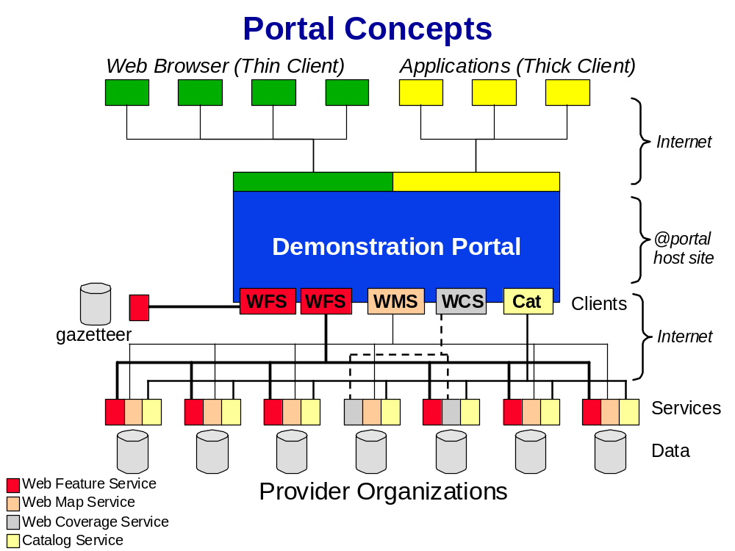

- PROJECT OBJECTIVES

The principal objectives of IDP are to:
- Demonstrate the benefits of interoperability for management of key national issues and assets, beginning with defence, security and emergency services
- Access data online from diverse government, academic and private databases, using OGC specifications
- Greatly enhance spatial information support for industry and government decision making and research
- Promote understanding of the benefits of agreed standards and practices that facilitate data sharing and integration and the maintenance of current, accurate and complete spatial information databases
- Promote development of reference and geospatial web services capable of supporting and using an interoperable environment
- Develop technical knowledge and expertise of Australian industry and governments
- Facilitate new private sector services and export markets which value-add data accessed online using OGC specifications
- Communicate to data providers the efficiencies and market opportunities created by interoperability standards.

- STRATEGY FOR CONDUCTING THE PROJECT

Project Governance
ASIBA and OGC, both not-for-profit organisations, will form an unincorporated not-for-profit entity to conduct the IDP. OGC-Australia will assume OGC’s role when established.

ASIBA will be the lead agency and will be responsible for contractual commitments, project outcomes and general administrative and management functions.
OGC-Australia will be responsible for project implementation. Key decisions will be taken jointly.

A Management Advisory Committee, will guide strategic direction and oversee the implementation of the IDP. It will also link the IDP, industry and governments and will communicate the views of external stakeholders to management. Members will include:

- Mr Jack de Lange (ASIBA)
- Professor Ian Williamson or Professor Clive Fraser, both of University of Melbourne (Research Sector)

- Mr Jason Brown (Defence)
- Mr Michael Stokes (Member of the SME Consortium, CRC for Spatial Information, and active systems integrator/consultant)
- Mr Paul Trezise (Geoscience Australia)
- Mr Peter Loughrey (System Vendor)
- Mr Paul Kelly (ANZLIC - which brings multi-agency representation)
- Mr Tony Wheeler (Large Service Provider)
- Mr Carl Reed (OGC).

Key Positions and Roles
A senior qualified person will be appointed to lead and implement the IDP and be answerable to ASIBA. The Project Leader will be responsible for strategic leadership, overall management and accountability, project outcomes, external communications, extension and reporting to the Commonwealth and other stakeholders. He or she will answer to ASIBA.

Mr Maurits Van der Vlugt, Senior GIS Consultant with Sinclair Knight Merz and Systems Architect with OGC, will be appointed as Acting Project Leader in the short term, pending an appointment for the full term of the IDP.

ASIBA will provide management and administrative support. ASIBA executives, David Hocking and Jack de Lange will work closely with the Project Leader to ensure full support for the Project and will be responsible for operational management, finances and human resources. They will also take responsibility for compliance with the funding agreement with the Commonwealth, the consortium partnership agreement and financial arrangements of the consortium.

The above officers will be active members of the IDP Advisory Committee and will also ensure the provision of secretariat support to the Management Advisory Committee. Senior staff will be located in Sydney and Canberra.

Clerical staff will be engaged to undertake administrative and lower level managerial tasks including:

- Organising meetings of the IDP Management Committee
- Tendering processes and management of contracts and agreements
- Maintaining records of meetings, reports and other information
- Coordination and preparation of reports
- Financial processing, including cash and in-kind expenditure
- Equipment and facilities
- Communication and marketing
- Facilitating final audit.

OGC-Australia will recruit the technical experience and expertise of international organisations and companies. Also, Australian and international software providers will collaborate with data providers, including Commonwealth and state agencies, service providers and research institutions to provide additional specialist technical expertise to the IDP. This collaboration will ensure expert and comprehensive design and implementation of the IDP and widespread extension of new information, insights and applications.

Technical expertise to be provided by project supporters includes:

- System interoperability software
- Spatial data
- A metadata registry to allow search and discovery of data and other spatial web services
- Network integration skills
- Delivery mechanisms (including intra and internet communication), and
- Cross platform communication (i.e. ICT).

Linkages to Other Projects
The IDP will build on two earlier projects funded from the Technology Diffusion Grants Program; Geoinsight ($2 million) and the Spatial Information Technology Diffusion Project ($618,000).

Geoinsight enhanced awareness and understanding of how spatial information technologies can be used in emergency management. The proposed project will build on Geoinsight by demonstrating the practical use of spatial technologies in a real-life situation and methodologies for effective spatial data management. It will also develop a model for implementation.

The Spatial Information Technology Diffusion Project provided training in the use of spatial information technologies and enhanced understanding of opportunities within the industry. The SITDP generated strong interest in spatial information across a range of industry sectors, despite being focused on the surveying industry. The IDP will capture this interest by demonstrating real time access and application of spatial information from distributed, diverse data sources across multiple viewing platforms.

The first two projects focused on awareness, education and training. The IDP, on the other hand, will use real life critical incidents to demonstrate methodologies for effective spatial data management and a model for implementation.

The IDP process of managing a critical incident will highlight a range of interoperability issues, skills required for systems integrators, delivery methodologies and cross platform issues. It will identify strengths and weaknesses in the availability, compatibility, quality and timeliness of data, and will demonstrate the need for greater collaboration. It will also provide valuable insights into requirements for ensuring Australia is able to manage critical issues and will provide a basis for identifying skill shortages and network failures.

The project will also create a model for the ASDI and for the exchange of data.

- PROPOSED ACTIVITIES TO BE FUNDED BY THE GRANT

A detailed Budget for the project is at Section 8. The following tables present the project costs in the broad cost categories defined in Section 3.1 of the Customer Information Document and categorise them as ‘eligible’ or ‘ineligible’. A further breakdown of these costs into Grant and In-kind contributions is also provided.

Details of the contributions to the project by participating organisations will be finalised prior to the commencement of the project.

Project Costs | Eligible | Ineligible
Project Management (Wages and Salaries)  Project Management and Team Coordination  Project Initiation  Data Preparation  Solution Development  and Deployment  Recommendations for  Technology Take-up | $429,880  $161,040  $281,640  $437,040  $115,120
Software |  | $210,500
Hardware |  | $200,000
Domestic Travel and Living Expenses | $205,000
International Travel and Living Expenses | $34,500
Non Salary Administration | $30,000
Total | $1,694,220 | $410,500

Project Costs | Grant Contribution
Project Management (Wages and Salaries)  Project Management and Team Coordination  Project Initiation  Data Preparation  Solution Development  and Deployment  Recommendations for  Technology Take-up | $ 244,940  $ 95,520  $ 160,820  $ 218,520  $ 62,560
Software
Hardware
Domestic Travel and Living Expenses | $ 205,000
International Travel and Living Expenses | $ 34,500
Non Salary Administration | $ 30,000
Total | $1,046,860

- PROPOSED ACTIVITIES TO BE FUNDED BY IN-KIND CONTRIBUTIONS

Project Costs | In-Kind
Project Management (Wages and Salaries)  Project Management and Team Coordination  Project Initiation  Data Preparation  Solution Development  and Deployment  Recommendations for  Technology Take-up | $ 184,940  $ 65,520  $ 120,820  $ 218,520  $ 42,560
Software | $ 210,500
Hardware | $ 200,000
Domestic Travel and Living Expenses
International Travel and Living Expenses
Non Salary Administration
Total | $1,057,860

- CLAIMS AGAINST THE ASSESSMENT CRITERIA

- Ability of the project to contribute to Australian industry access to global technologies and best practices and to facilitating their uptake by Australian firms, particularly SMEs.

IDP will have ready access to global technologies and best practice through relationships with organisations such as the OGC, the Geospatial Information & Technology Association and their respective members and associates.

OGC, for example is building the Geospatial One-Stop Portal to distribute geospatial data from all levels of government. As with the proposed IDP, this portal is being developed to support improved service for planning, disaster response, homeland security, and many other activities.

The IDP will also draw heavily on OGC’s OpenGIS® Catalog Services Interface Specification. Catalogs are online registries of metadata that facilitate discovery and access to web-accessible data and services.
The Specification provides a framework so that multiple catalogs can be "viewed" as one catalogue.

OGC interface standards have proved crucial for planning and responding to emergencies from natural disasters to terrorism, enabling data held by numerous agencies to be accessed, shared and displayed. Also OGC's pilot projects have confronted many issues that will face the IDP, such as security, access and liability. The IDP will not face the same learning curve because the outcomes of these overseas pilots will be available to the Australian project.

The Australian Spatial Data Infrastructure (ASDI) will be enhanced by the development of the IDP. The IDP complements ASDI’s aim of ensuring that users of spatial data can acquire consistent datasets, even though the data is collected and maintained by different authorities.

It must also be recognised that access to global technologies and best practice is a two way street. Australia’s ongoing access to global experience and expertise will be influenced by the extent to which we develop our industry and share our own learnings.

To create a base for a competitive export industry it is important to grow the industry in Australia. Accordingly, the demonstration of interoperability specifications and technologies, and the intellectual property developed through the IDP, will be made available to all participants in the Australian spatial industry. SMEs, such as integrators of spatial, communications and information technology, comprise the major part of the spatial industry, so they will be major beneficiaries of the IDP.

Based on the learnings from the IDP, strategies will be developed to engage and facilitate uptake by SMEs. These could include online resources readily accessible to industry and governments, a hotline, best practice manuals and training workshops.

b) Capability to conduct the project
The management of the project will draw on the demonstrated competence and technical skills of staff from the participating organisations. The IDP will also build on the two successful projects, Geoinsight and the Spatial Information Technology Diffusion Project, which were funded from the Technology Diffusion Grants Program. The management of the IDP has had some involvement in these projects and will transfer their experience and expertise to the IDP.

Project Leader
Mr Maurits Van der Vlugt, Senior GIS Consultant, Sinclair Knight Merz and Open GIS Systems Architect (Active in OGC international projects).

Mr Maurits Van der Vlugt is a highly qualified technical expert. His technical expertise will be available in the early stages of the IDP through his role as Acting Project Leader. Following recruitment of a full term leader Mr Van der Vlugt will continue to contribute his expertise to the IDP by participating in the Management Committee

At Sinclair Knight Merz, Maurits is responsible for Geo-IT service delivery throughout Australasia. He provides strategic and technical consulting services with a focus on systems integration, web services delivery, distributed systems and spatial data standards. He has extensive experience in Europe, the USA and Australia, consulting organisations on spatial interoperability strategies and developing creative solutions for real world problems.

Maurits has deep working knowledge of geographic information technology, urban planning and transportation issues. As a member of the ASDI (Australian Spatial Data Infrastructure) Technical Working Group, he is involved in the design of the ASDI Project Management.

David Hocking (Grad Cert. Mgmt., Dip. OH&S Mgmt.) will be responsible for ASIBA’s contribution. He is an experienced management professional with a successful record in business development and promotion across a range of public, private, academic, commercial and association forums.

He has held senior leadership positions in professional, research and business associations. David has served on the steering committee of the successfully completed Spatial Information Industry Technology Diffusion Project, and is a member of the Spatial Information Industry Action Agenda Implementation Joint Standing Committee.

David is Chief Executive Officer of ASIBA and the Association of Consulting Surveyors Australia.

Jack de Lange (B. Surv, Grad Dip. Quality) has worked in the spatial information industry for over 30 years at all levels from operational to senior management, in both the public and private sectors.

Since 1990 he has been an association executive within the spatial information industry and he has the rare combination of broad industry knowledge and modern management and communication technologies skills.

Jack is currently serving in the dual roles of Chief Operating Officer for ASIBA and Chief Executive Officer of Spatial Queensland.

(c) Benefit to Australia
The economic significance of the IDP project is reflected in the following statement by the Hon Nick Minchin, former Minister for Industry Science and Resources, from Positioning for Growth, Spatial Industry Action Agenda, September 2001:
- “Ready and timely access to spatial information – knowing ‘where’ people and objects are – is essential to Australia’s continued development in the information age. It is a critical tool in informed decision making on key economic, environmental and social issues.”
- “Australia’s future prosperity depends to a significant extent on how well our industries compete in the global information economy.”

A new wave of technological innovation is allowing the to capture, storage, processing and displaying an unprecedented amount of information. Much of this information will be referenced to a specific place. As a consequence, spatial information and associated location based services are now widely recognised as key drivers of growth in the information technology sector. Global expenditure in spatial information is in the order of $34 billion pa and is growing at 20% pa. The Australian industry has a turnover exceeding $1 billion and it is an important part of our new economy.

Studies show a five-fold return on investment in spatial information because it is a fundamental input to many other industries. Major industry users include defence, national security, emergency services, transport, telecommunications, asset and environmental management and planning, design and development. It is now a vital component of decision making that has political, economic, environmental and social ramifications.

In order to achieve the Australian spatial industry’s vision of being a global leader in the innovative provision and use of spatial information, and to ensure the competitiveness of Australian industry, it is vital to remove the impediments to the development of the industry.

Limited interoperability is one of the key impediments to development of the spatial industry. By taking a lead on this issue Australia will position itself at the forefront of the global spatial industry, creating both domestic and export markets for its new knowledge.

d) Evidence of industry or other support
The IDP project has the support of a wide range of government and private sector organisations, as evidenced by the letters of support attached to this submission.
In addition, Australian and international software providers will collaborate with data providers, including Commonwealth and state agencies, service providers and research institutions to provide additional specialist technical expertise to the IDP. This collaboration will ensure expert and comprehensive design and implementation of the IDP and widespread extension of new information, insights and applications.

Examples of the technical expertise to be provided by project supporters include:
- System interoperability software
- Spatial data
- A metadata registry to allow search and discovery of data and other spatial web services
- Network integration skills
- Delivery mechanisms (including intra and internet communication), and
- Cross platform communication (i.e. ICT).

e) Priorities and measurable outcomes
The IDP falls within the Industry Action Agenda “Spatial Information Industry’ and will enhance industry competitiveness in this sector and the economy generally. The IDP will demonstrate:
- The availability and value of interface specifications and interoperability technologies to Australian industry,
- Immediate access to and use of existing web services owned by multiple entities, and
- Use of a searchable catalogue using international and national standards (e.g. ISO, ANZLIC) and Open GIS specifications.

Some of the key outcomes from the IDP will include:
- Greatly enhanced spatial information support for industry and government decision making
- The development of skills and expertise by Australian systems integration firms
- Exposure of duplication by data collectors
- Understanding of the benefits of agreed standards and practices to facilitate data sharing and integration
- Improved technical knowledge and expertise among industry and governments
- Partnerships within and between governments and business in order to maintain current, accurate, and complete spatial information databases for the decision-making needs of all parties
- New export markets based on the expertise and intellectual property flowing from the IDP
- Shaping of the research and policy agenda for this industry sector
- Strategies for building the national spatial data infrastructure
- Increased investment in the sector by Australian industry, and
- Raised international standing for Australia.

f) Need for funding.
The amount of funding sought is vital to the progress of the IDP. Participants will contribute 50.3% in cash and in-kind , but without the matching contribution from the Innovation Access Program it would not be possible for the IDP to proceed.

The development of interoperability is a high global and national priority. For Australia to be able to manage its assets and critical emergency and security incidents effectively, to improve industry and government decision making, and to compete globally, the issues involved in this project need to be dealt with as a matter of urgency.

The Commonwealth’s financial support is crucial to establishing the momentum needed for this project to be accomplished in the short to medium term.

- BUDGET

A detailed budget for the project is at Attachment A. The estimated cost of the project is $2,104,720 over a twelve month period.

- KEY STAFF

Key staff for the IDP are David Hocking, Jack de Lange and Maurits van der Vlugt, whose roles and capabilities are indicated above in Section 7b. Detailed CVs will be forwarded separately.

- MILESTONES

An indicative timeframe for the project and key milestones are presented in the table below.

Time | Activity
June – August 2003 | Project Initialisation – completion of scope and functional requirements  Finalise agreement between participants
September – January 2003/04 | Trial implementation and pilot rollout
Feb – March 2004 | Implementation to all participants
April 2004 | Complete full testing
May –June 2004 | Full blown high profile demonstration and industry marketing campaign
May June 2004 | Concurrent preparation of outcomes and way forward report

- LETTERS OF SUPPORT

We have very positive support from a broad range of participants. The proposed participants can be broadly split into 4 categories. These are:

- Software and Hardware providers,
- Data Providers and End User Organisations (which tend to be predominantly Government organisations),
- Service providers (consultants and systems integrators), and
- Research Organisations.

The emphasis on the IDP is on benefits to defence, security and emergency services. Accordingly, it is important to get participation from the utility organisations that maintain the underground services whose protection from attack or natural damage is crucial to Australian communities’ daily activities. These important services include:

- Communications towers and cables
- Gas and electricity
- Water supply, and
- Stormwater and sewage disposal.

Relevant organisations have been approached to gauge their interest in participating. We have attached letters of support from those that have responded in the tight timeframe of preparing this submission. Further letters of intent will follow by 30 April 2003.

See Section 2 (Background/Introduction) above for a detailed list of organisations being invited to participate.

- OTHER

Table 3 shows the general categories of activities and support to be provided by participating organisations.

The details of contributions by these organisations will be negotiated and confirmed prior to the commencement of the project

Table 3: Activity/Support from Participating Organisations

Participant | Activity/Support
ESRI Australia | Provision of software and services for deployment
Intergraph Australia | Provision of software and services for deployment
Mapinfo Australia | Provision of software and services for deployment
Amristar | Provision of software and services for deployment
Oracle | Provision of software and services for deployment
Land and Property Information NSW (LPI NSW) | Potential cash sponsor and data provider
Public Sector Mapping Agencies Australia (PSMA) | Data provider
Environment Australia | Potential cash sponsor and data provider
Geoscience Australia | Potential cash sponsor and data provider
Western Australian Land Information System (WALIS) | Data provider
Community Access to Natural Resources Information (CANRI) | Data provider and in – kind participant
National Oceans Office (NOO) | Stakeholder
National Office for the Information Economy (NOIE) | Stakeholder
Australian Antarctic Division (AAD) | Stakeholder
National Land and Water Resources Audit (NLWRA) | Potential cash sponsor and data provider
Queensland Spatial Information Industry Strategy (QSIIS) | In-kind participant
Telstra | Potential cash sponsor and data provider
TXU Australia | Data provider
Citipower | Data provider
Powercor | Data provider
Sydney Water | Data provider
Sinclair Knight Merz | In - kind participant, systems design and integration
Social Change Online | In – kind participant, systems design and integration, software provider
Navigate | In - kind participant, systems design and integration
Boeing | In - kind participant, systems design and integration, and potential cash sponsor
Raytheon | In - kind participant, systems design and integration, and potential cash sponsor
Geomatic Technologies | In - kind participant, systems integration, software provider
SAAB Systems | In - kind participant, systems design and integration, and potential cash sponsor
Itech Systems | In - kind participant, systems design and integration
OGC-A | In - kind participant, systems design and integration
SUN Microsystems | Provider of Computer Hardware, web servers
SGI | Provider of Computer Hardware, web servers
University of Sydney | In – kind research activities
CSIRO | In – kind research activities
Centre for Spatial Data Infrastructures and Land Administration | In – kind research activities and linking in with its programs
CRC for Spatial Information | In – kind research activities and linking in with its programs

Attachment A

ASDI Interoperability Demonstration Project Preliminary Budget
Task/Unit | Days/Units | Personnel | D/Rate (A$) | Amount (A$)
Project Management
Project Management & Team Coordination | 75 | PM | $1,280 | $96,000 | In addition to rhe PM allocation in the tasks below
Financial Management | 24 | PA | $1,200 | $28,800
Independent Audit | 8 | C | $1,440 | $11,520
Project Facilitation and Communication | 25 | PA | $1,200 | $30,000
Contract Management and Reporting | 38 | PM | $1,280 | $48,640
 | 50 | PA | $1,200 | $60,000
Tendering for Service Providers | 15 | PA | $1,200 | $18,000
Team Workshops | 6 | PM | $1,280 | $7,680 | 6 Proposed for 12 Participants over duration of project
 | 6 | TA | $1,600 | $9,600
 | 6 | SD | $960 | $5,760
 | 6 | SD | $960 | $5,760
 | 6 | SI | $1,120 | $6,720
 | 6 | SI | $1,120 | $6,720
 | 6 | SI | $1,120 | $6,720
 | 6 | SA | $1,280 | $7,680
 | 6 | SA | $1,280 | $7,680
 | 6 | DS | $880 | $5,280
 | 6 | DS | $880 | $5,280
 | 6 | DS | $880 | $5,280
Final Demonstration | 3 | PM | $1,560 | $4,680
 | 3 | SA | $1,280 | $3,840
 | 3 | DS | $880 | $2,640
 | 3 | DS | $880 | $2,640
 | 3 | DS | $880 | $2,640
Project Reviews | 12 | PD | $1,760 | $21,120
Steering Committee Meetings | 3 | PSC | $6,400 | $19,200
Sub Total |  |  |  |  | $429,880
Project Initialisation
Finalise Scope and Prepare Project Plan | 15 | PM | $1,280 | $19,200
 | 5 | PD | $1,760 | $8,800
 | 15 | SA | $1,280 | $19,200
 | 5 | TA | $1,600 | $8,000
Functional Requirements | 5 | PM | $1,280 | $6,400
 | 10 | TA | $1,600 | $16,000
 | 15 | SA | $1,280 | $19,200
 | 15 | SA | $1,280 | $19,200
 | 2 | IE | $2,800 | $5,600
Test Plan | 5 | TA | $1,600 | $8,000
 | 3 | PM | $1,280 | $3,840
 | 1 | IE | $2,800 | $2,800
 | 5 | SA | $1,280 | $6,400
Acceptance Criteria | 1 | PSC | $6,400 | $6,400
Finalise Budget | 5 | PM | $1,280 | $6,400
Expert Review | 2 | IE | $2,800 | $5,600
Sub Total |  |  |  |  | $161,040
Data Acquisition
Finalise scope of datasets required | 2 | PM | $1,280 | $2,560
 | 2 | TA | $1,600 | $3,200
Arrange Access to Datasets from State & Comm Govt Participants | 15 | DS | $880 | $13,200
 | 5 | PM | $1,280 | $6,400
Arrange Access to Datasets with Utilities and Private Sector Participants | 15 | DS | $1,560 | $23,400
 | 5 | PM | $1,280 | $6,400
Data Preparation
DEMS | 10 | DS | $880 | $8,800
Imagery | 48 | DS | $880 | $42,240
Cadastre | 5 | DS | $880 | $4,400
Underground Services | 68 | DS | $880 | $59,840
Street Network | 5 | DS | $880 | $0
Street Address | 10 | DS | $880 | $8,800
Topographic | 5 | DS | $880 | $4,400
Other Specialist datasets | 20 | DS | $880 | $17,600
Data Preparation | 30 | DS | $880 | $26,400
 | 90 | DA | $600 | $54,000
Sub Total |  |  |  |  | $281,640
Solution Development and Deployment
Systems Architecture | 15 | SA | $1,280 | $19,200
 | 3 | TA | $1,600 | $4,800
 | 3 | PM | $1,280 | $3,840
 | 2 | IE | $2,800 | $5,600
Platform Preparation | 3 | SA | $1,280 | $3,840
 | 5 | SI | $1,120 | $5,600
 | 5 | SI | $1,120 | $5,600
 | 5 | SI | $1,120 | $5,600
 | 5 | SI | $1,120 | $5,600
 | 5 | SI | $1,120 | $5,600
 | 2 | TA | $1,600 | $3,200
 | 2 | PM | $1,280 | $2,560
Initial Working Demonstrator | 5 | SA | $1,280 | $6,400
 | 5 | SA | $1,280 | $6,400
 | 25 | SI | $1,120 | $28,000
 | 25 | SI | $1,120 | $28,000
 | 25 | SI | $1,120 | $28,000
 | 25 | SI | $1,120 | $28,000
 | 2 | TA | $1,600 | $3,200
 | 1 | IE | $2,800 | $2,800
 | 5 | PM | $1,280 | $6,400
Review and Re-spec | 5 | TA | $1,600 | $8,000
 | 1 | IE | $2,800 | $2,800
 | 5 | SA | $1,280 | $6,400
 | 5 | TA | $1,600 | $8,000
Re-Develop and Enhance | 5 | SA | $1,280 | $6,400
 | 5 | SA | $1,280 | $6,400
 | 25 | SI | $1,120 | $28,000
 | 25 | SI | $1,120 | $28,000
 | 25 | SI | $1,120 | $28,000
 | 25 | SI | $1,120 | $28,000
 | 2 | TA | $1,600 | $3,200
 | 1 | IE | $2,800 | $2,800
 | 5 | PM | $1,280 | $6,400
Test and Review | 5 | SA | $1,280 | $6,400
 | 5 | SA | $1,280 | $6,400
 | 5 | SA | $1,280 | $6,400
 | 5 | TA | $1,600 | $8,000
 | 2 | IE | $2,800 | $5,600
Roll Out | 10 | SI | $1,120 | $11,200
 | 10 | SI | $1,120 | $11,200
 | 10 | SI | $1,120 | $11,200
Sub Total |  |  |  |  | $437,040
Recommendations for Technology Takeup
Review of Project Success and Recommendations to enable Industry to Realise Benefits | 10 | PM | $1,280 | $12,800
 | 25 | C | $1,440 | $36,000
Industry Survey | 20 | C | $1,440 | $28,800
Complete Report | 20 | C | $1,440 | $28,800
 | 2 | PM | $1,560 | $3,120
 | 2 | IE | $2,800 | $5,600
Sub Total |  |  |  |  | $115,120
Software Bundles
Mapinfo | 1 |  |  | $35,000
ESRI | 1 |  |  | $37,000
Intergraph | 1 |  |  | $32,000
Autodesk | 1 |  |  | $22,000 | Supplied by Geomatic Technologies
Oracle | 1 |  |  | $15,000
Social Change Online | 1 |  |  | $30,000
Amristar |  |  |  | $25,000
Other Software |  |  |  | $14,500
Sub Total |  |  |  |  | $210,500
 | 1
Hardware
Dual CPU Web Server (Sun ) | 3 |  | $25,000 | $75,000
Dual CPU Web Server (SGI ) | 3 |  | $25,000 | $75,000
Disk Storage / Hosting Facility | 5 |  | $10,000 | $50,000
Sub Total |  |  |  |  | $200,000
Miscellaneous Expenses |  |  |  |  | Estimates Only - Travel and Accom charged at cost - Upper limits shown
Travel (Meetings to be held in 1 of Syd, Canb, Melb) | 180 | Various | $500 | $90,000 | Average Cost of Trip from anywhere in Australia
Accommodation/Meals | 460 | Various | $250 | $115,000
Travel International | 4 | Various | $6,000 | $24,000 | Assume Discount Bus Class Required for the International Experts
Accommodation & Meals for International Visitors | 42 |  | $250 | $10,500
Publishing of Report | 1 |  |  | $30,000 | Hard Copy, CDs and Web Site
Sub Total |  |  |  |  | $269,500
Grand Total |  |  |  | $2,104,720

